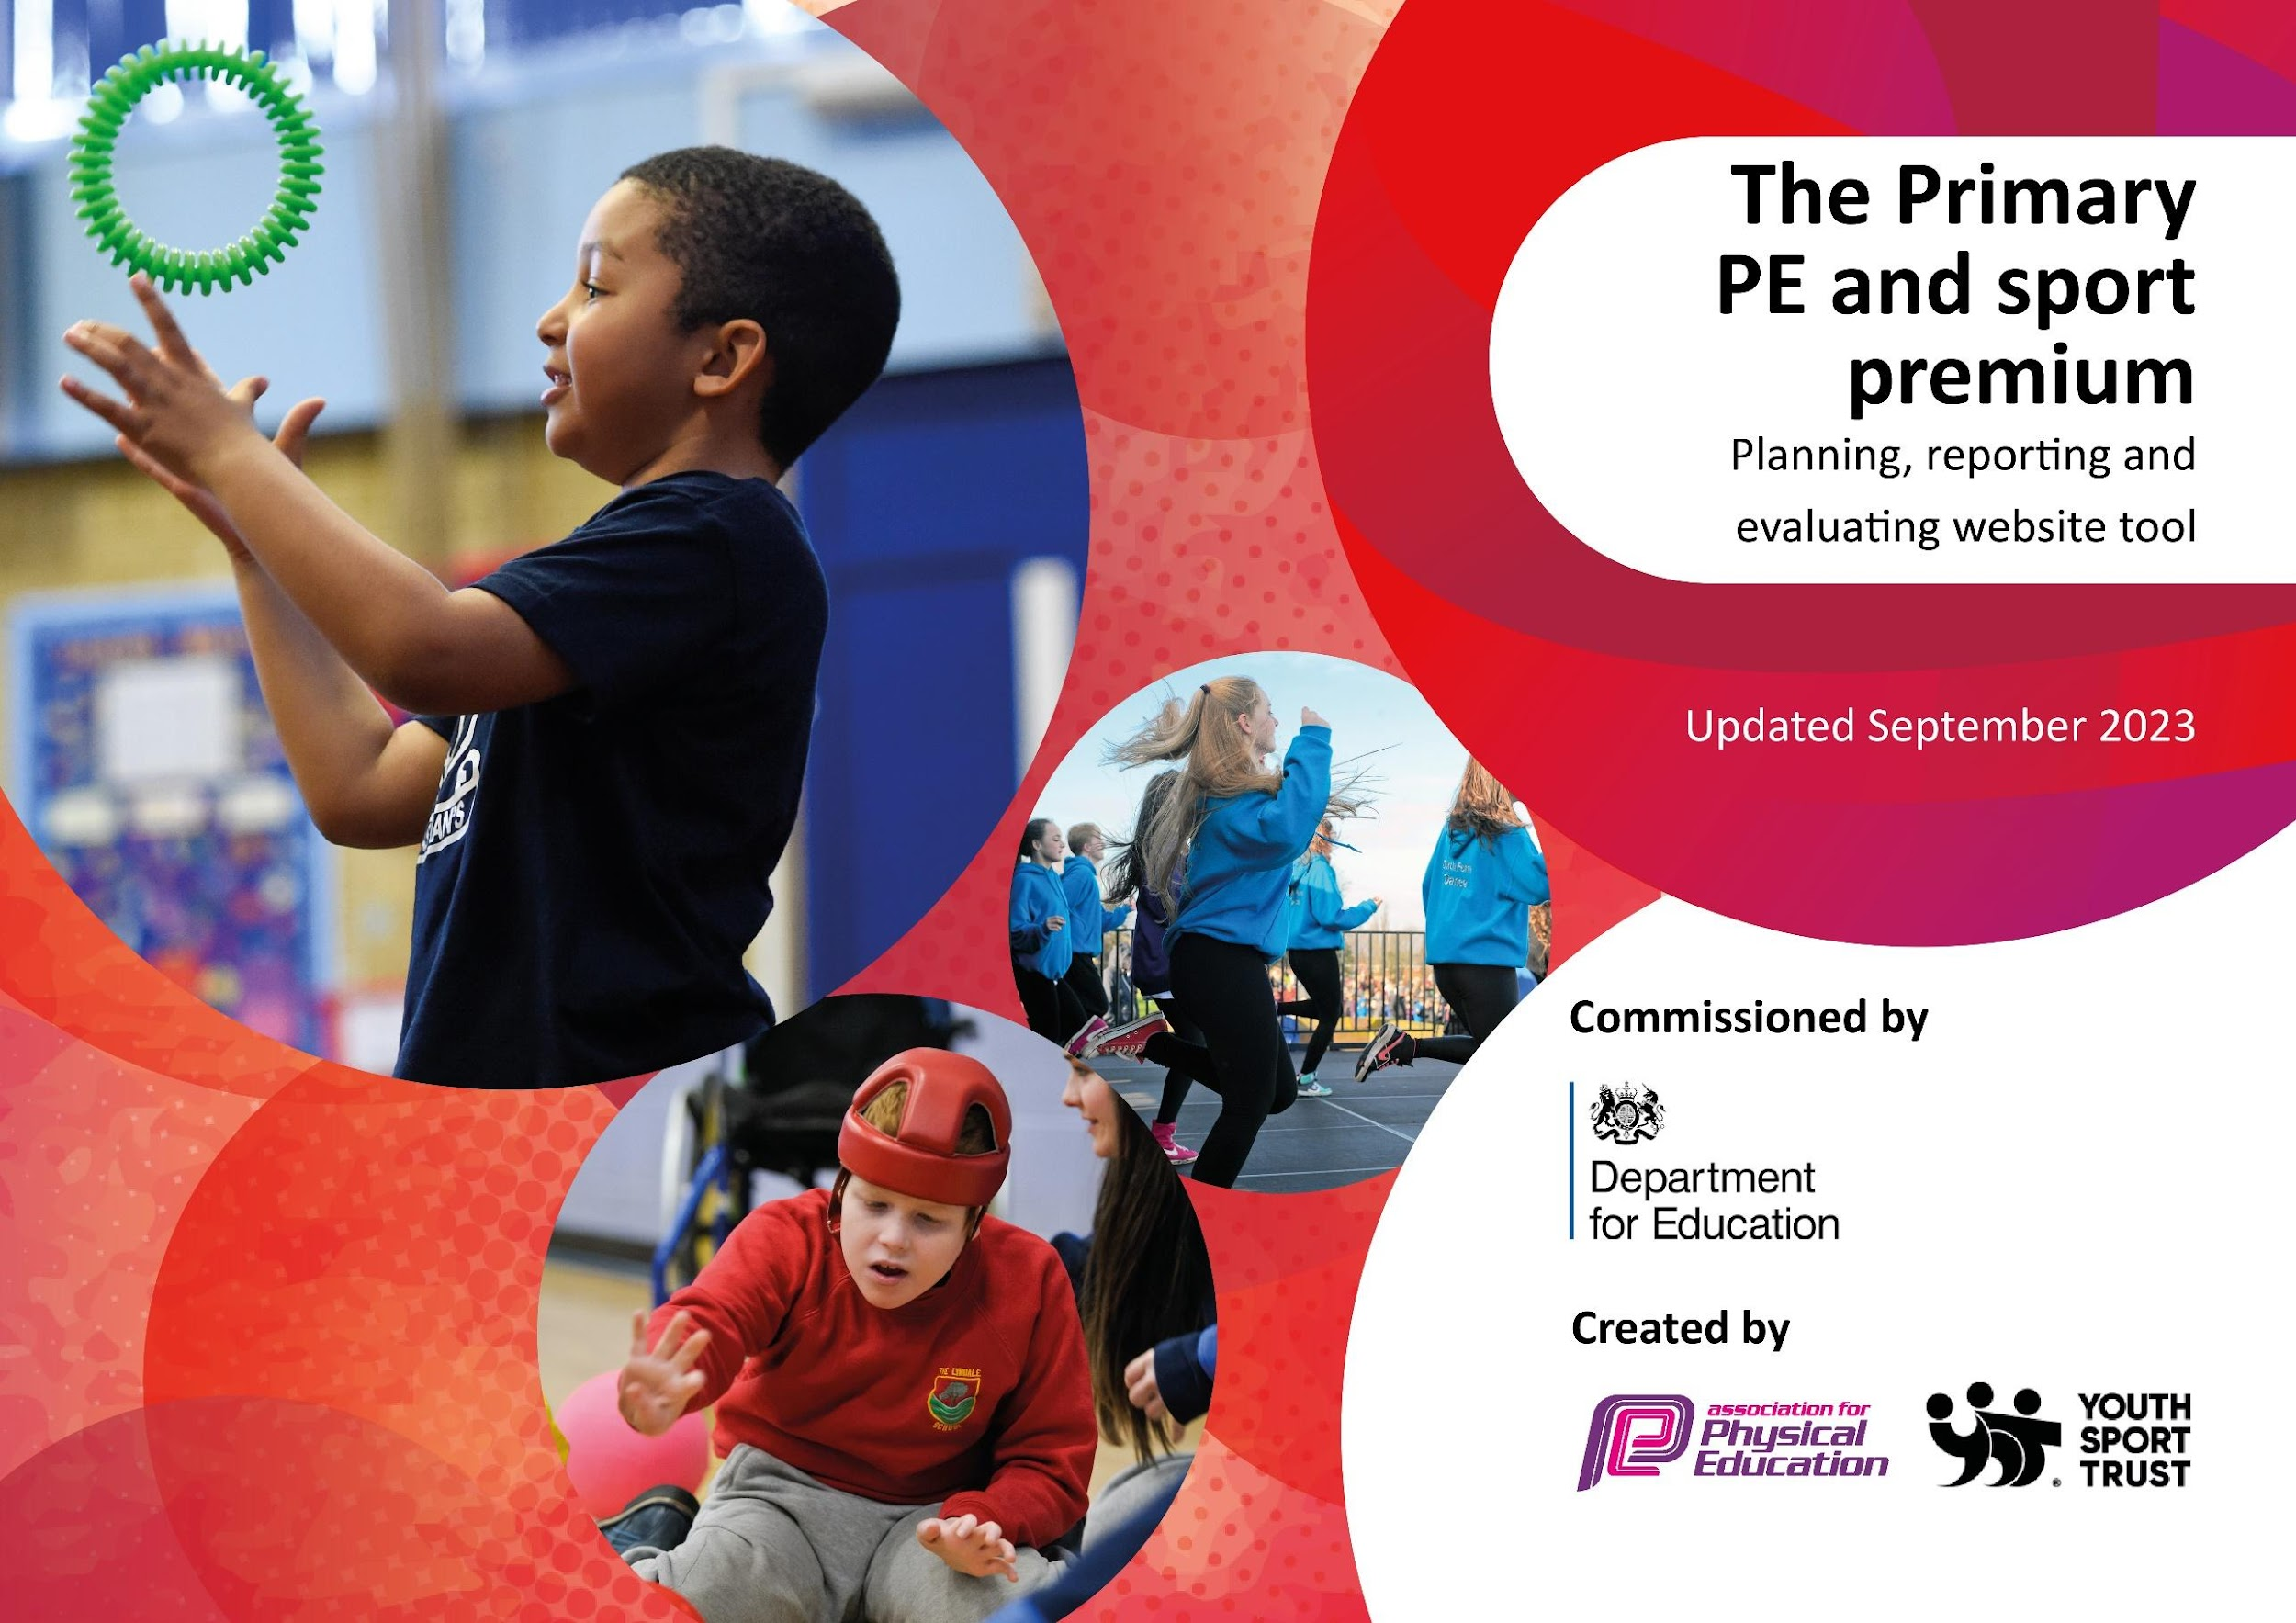

SHERRIER CE PRIMARY SCHOOL
PE STRATEGY 2023-2024

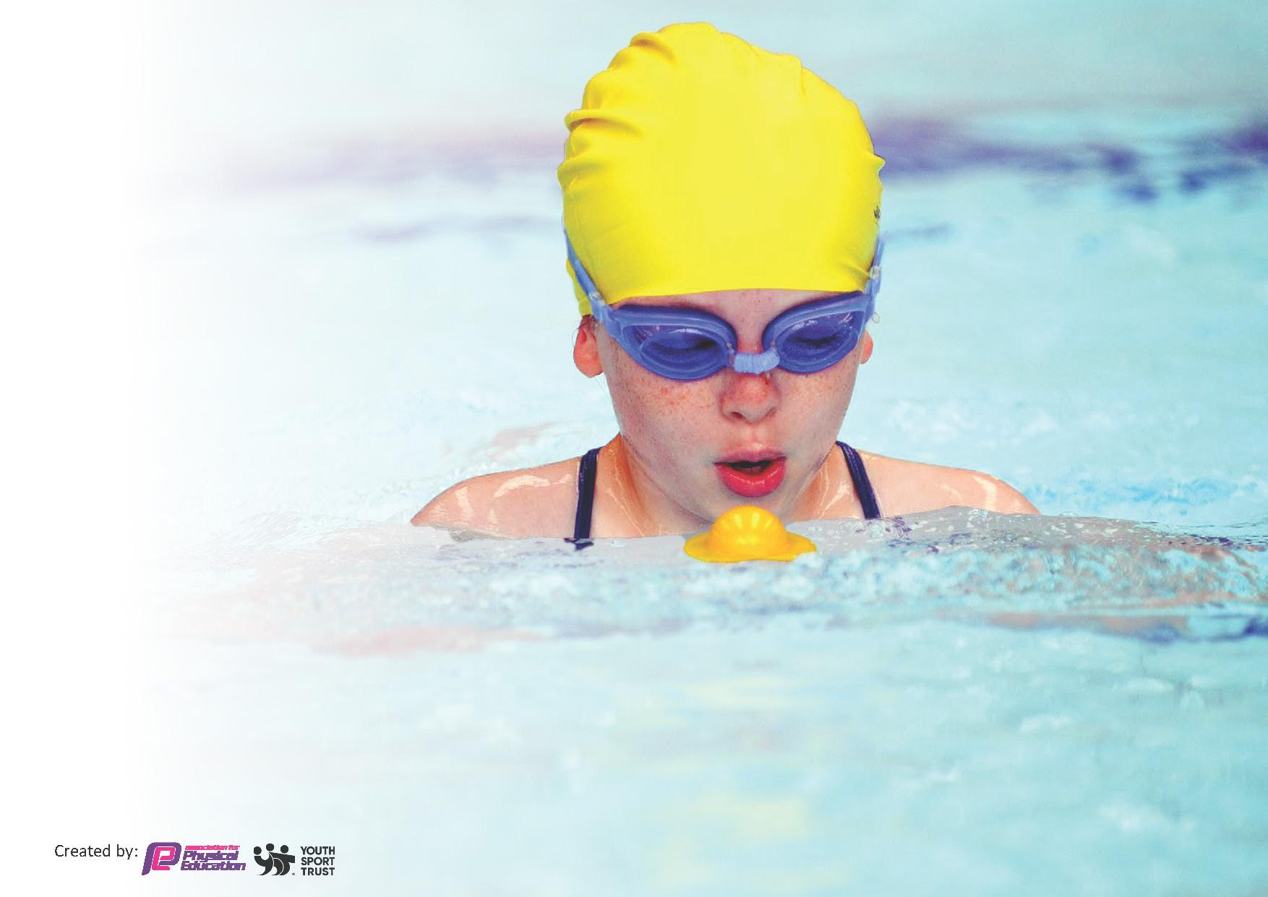
This template can be used for multiple purposes:
by:
- It enables schools to effectively plan their use of the Primary PE and sport premium
- It helps schools to meet the requirements (as set out in guidance) to publish information on their Primary PE and sport premium
- It will be an effective document to support Ofsted inspections enabling schools to evidence progress in Physical Education (PE) and evidence swimming attainment, which forms part of the PE National Curriculum. We would recommend schools consider
the Intent, Implementation and Impact of any spend, as examined within the Education Inspection Framework.

It is important that your grant is used effectively and based on school need.

Schools must use the funding to make additional and sustainable
improvements to the quality of the PE, School Sport and Physical Activity (PESSPA)
they offer. This means that you should use the Primary PE and sport premium to:

- Build capacity and capability within the school to ensure that improvements made now will benefit pupils joining the school in future years
- Develop or add to the PESSPA activities that your school already offers.

The Primary PE and sport premium should not be used to fund capital spend projects; the school’s core budget should fund these. Further detail on capital expenditure can be found in the updated Primary PE and sport premium guidance.
Review of last year’s spend and key achievements (2022/2023)

We recommend you start by reflecting on the impact of current provision and reviewing your previous spend.

Activity/Action | Impact | Comments
- To engage all pupils in regular physical activity and undertake at least 30 mins of physical activity a day in school. | The uptake for after school club provision overall this year has been quite low. This does not mean they are not worthwhile, however on investigation this is because a lot of Sherrier children already attend their own external sports/dance/drama etc clubs in the local area after school.  Enrichment provision in school time was successful with 98% of KS2 children attending a lunchtime sporting club led by a sports coach. This also offered a physical activity during lunchtimes.  Happy Lunchtimes was introduced and this allowed for more physical activities like skipping, netball etc to be played during lunchtime and led by a TA.  ‘Inclusive games’ for SEND/PP children, ‘Boys Do’, ‘Energise Club’ for less active pupils and the ‘Girls Active’ events increased chidlren’s awareness to physical activity and allowed them to engage in sports/activities they would not normally get the chance to participate in.  ‘Move it March’ event in March 2023 saw 328 pupils out of 413 (79%) take part in being more active during the day. We continued with this approach by keep raising awareness of messages to parents about being active, promoting active events and clubs beyond school, inviting clubs into school more and having sports people in to do assemblies for children.  The school achieved the ‘Enhanced Healthy School’ Gold award for our efforts to children’s physical exercise participation and health and wellbeing. | The school made a conscious effort to increase enrichment provision in school utilizing the children’s responses to more varied clubs to be on offer. The school targeted girls, SEND and PP children. We offered Martial Arts, Football, Multi-Skills, Gymnastics, Basketball, Dodgeball, Archery, Robotics, Choir, Drama and Dance, and art.  We have seen the success of our increased active participation because we invested in having a sports coach in place to deliver key enrichment clubs and raise awareness to our community by increasing messages home to parents about PE and the benefits on our wellbeing if we participate in exercise.

Key priorities and Planning 2023-2024

Action – what are you planning to do | Who does this action impact? | Key indicator to meet | Impacts and how sustainability will be achieved? | Cost linked to the action
To train 4 students in year 5/ 6 to be Sports Ambassadors for the school. The ambassadors will form a School Sport Organising crew and devise an action plan to promote PE and physical activity in school.  To train 20 student Playground Leaders in Year 5/6  To train 4 Well-being Ambassadors in Year 5 /6 to promote the 5 Ways to Well-being and Internet Safety. Being Active is one of the 5 Ways to Well-being.  To participate in Active Travel Month. During October 2023, students and families will be encouraged to walk,cycle or scoot to school. A wallchart will be given to every class to record the number of children actively travelling to school. A trophy will be given to the class that actively travelled the most.  To take part in the Move It March project. Each child will be given a physical activity tracker to fill out during March 2023. Certificates and prizes will be awarded to children who achieve physical activity milestones (250 active minutes=Bronze, 500 active minutes=Silver, 750 active minutes=Gold and 1000 active minutes=Platinum). Pupils will also be given points for achieving milestones and the most active class will win a trophy.  To take part in the SLSSP Big Moves project designed for EYFS/KS1 pupils who lack fundamental movement skills. A coach from the SLSSP will deliver 6 sessions to 15 targeted pupils. The pupils undergo a fundamental movement assessment on week 1 and 6 to evaluate the impact of the intervention. A member of staff will supervise the sessions and attend a Big Moves training course.  The school plans to take part in the Aspiration Active project, which is 5 weeks of activity for less active pupils in year 5/6. The target group will choose the activities. The participants will be invited to an Aspiration Active celebration event at the local leisure centre. The pupils will take part in a range of activities. The aim of the event was to signpost the participants to local community exit routes.  The school will deliver an Inclusive Sport Club targeting SEND pupils. A coach from the SLSSP will deliver a 5 week club alongside a member of staff. The coach will deliver Boccia, New Age Kurling and Sitting Volleyball sessions.  To take part in sports competitions and events (including the less sporty/active children). We also aim to take part in sports festivals to aid transition to secondary schools.  Pupils will take part in DEVELOP festivals, which are designed to be fun and deliver sport specific skills. These events are designed for less sporty/active pupils.  These events include:  Aspiration Active, Football Festivals, Multi Skills Festivals, Sportsability, Tag Rugby Festival, Hockey, Girls Football, Tennis and Dance.  Pupils will take part in EXCEL competitions which are designed for our most able pupils and are based on performance.  These events include:  Table Tennis, Girls Football, Mixed Football, Cross Country, Indoor Athletics, Basketball, Dodgeball, Hockey, Netball, Swimming, Tennis, Touch Rugby and Area Sports.  To take part in the SLSSP’s Quad Cup virtual competitions. The personal/team challenges are designed to give all students the opportunities to take part in a competition and learn sport specific skills/develop a love for physical activity.  The virtual competitions we will take part in includes:  Move it March and Active Travel.  To introduce Staff Well-being Ambassadors. The ambassadors will take part in physical activity and mental health training. The ambassadors will devise an action plan to support staff well-being. The ambassador will be given funding to support their action plan. | Pupils – the ambassadors will promote physical activity and deliver activities to younger pupils. To engage pupil voice and use students’ leaders to raise the profile of PE and School Sport.  Lunchtime Supervisors and KS2 pupils- The Playground Leaders will deliver active games to students during lunch times. The Lunchtime Supervisor will oversee the ‘Happy Lunchtime’ sessions and deliver active games to the KS1 and 2 pupils during lunchtimes.  Pupils- to engage pupil voice and use students’ leaders to promote a healthy and active lifestyle to their peers.  Pupils- as they will take part.  All pupils-as they will be encouraged to take part.  All staff will be encouraged to take part.  Targeted Pupils- who took part in the programme.  A member of staff- who was trained to deliver the programme in school.  Targeted Pupils- who took part in the programme.  SEND Pupils- who took part in the programme.  Member of staff-to support sessions and learn about Inclusive Sports that can be delivered to SEND pupils  Pupils- who took part in the events/competitions  Pupils- who took part in the events/competitions  Staff-the ambassadors will promote physical activity and mental well-being. The ambassadors will deliver interventions to support staff well-being. | Key indicator 2 -The engagement of all pupils in regular physical activity – the Chief Medical Officer guidelines recommend that all children and young people aged 5 to 18 engage in at least 60 minutes of physical activity per day, of which 30 minutes should be in school.  Key indicator 3: The profile of PESSPA being raised across the school as a tool for whole school improvement  Key indicator 2 -The engagement of all pupils in regular physical activity – the Chief Medical Officer guidelines recommend that all children and young people aged 5 to 18 engage in at least 60 minutes of physical activity per day, of which 30 minutes should be in school.  Key indicator 3: The profile of PESSPA being raised across the school as a tool for whole school improvement  Key indicator 3: The profile of PESSPA being raised across the school as a tool for whole school improvement  Key indicator 2 -The engagement of all pupils in regular physical activity – the Chief Medical Officer guidelines recommend that all children and young people aged 5 to 18 engage in at least 60 minutes of physical activity per day, of which 30 minutes should be in school.  Key indicator 3: The profile of PESSPA being raised across the school as a tool for whole school improvement  Key indicator 2 -The engagement of all pupils in regular physical activity – the Chief Medical Officer guidelines recommend that all children and young people aged 5 to 18 engage in at least 60 minutes of physical activity per day, of which 30 minutes should be in school.  Key indicator 3: The profile of PESSPA being raised across the school as a tool for whole school improvement  Key indicator 1: Increased confidence, knowledge and skills of all staff in teaching PE and sport  Key indicator 2 -The engagement of all pupils in regular physical activity – the Chief Medical Officer guidelines recommend that all children and young people aged 5 to 18 engage in at least 60 minutes of physical activity per day, of which 30 minutes should be in school.  Key Indicator 4- Broader experience of a range of sports and activities offered to all pupils  Key indicator 2 -The engagement of all pupils in regular physical activity – the Chief Medical Officer guidelines recommend that all children and young people aged 5 to 18 engage in at least 60 minutes of physical activity per day, of which 30 minutes should be in school.  Key Indicator 4- Broader experience of a range of sports and activities offered to all pupils  Key indicator 1: Increased confidence, knowledge and skills of all staff in teaching PE and sport  Key indicator 2 -The engagement of all pupils in regular physical activity – the Chief Medical Officer guidelines recommend that all children and young people aged 5 to 18 engage in at least 60 minutes of physical activity per day, of which 30 minutes should be in school.  Key Indicator 4- Broader experience of a range of sports and activities offered to all pupils  5.Increased participation in competitive sport  Key Indicator 4- Broader experience of a range of sports and activities offered to all pupils  5.Increased participation in competitive sport  Key Indicator 4- Broader experience of a range of sports and activities offered to all pupils  Key indicator 3: The profile of PESSPA being raised across the school as a tool for whole school improvement  Key Indicator 1: Increased confidence, knowledge, and skills of all staff in teaching PE and sport.  Key indicator 3: The profile of PESSPA being raised across the school as a tool for whole school improvement | The ambassadors took control of a PE and school sport noticeboard.  The notice board includes the physical activity guidelines infographics. Younger students were encouraged to submit pictures of themselves taking part in physical activity and pupils’ sporting achievements were included on the noticeboard.  Sporting achievements were also celebrated in assemblies. The school newsletter contains information about physical activity, sports clubs and fixtures.  The school continues to train and give opportunities to the Sports Ambassadors. A new cohort of Sports Ambassadors will be trained next year to ensure student voice is represented in the school’s physical activity offer  More pupils meeting the physical activity guidelines. Children are more active at lunch times.  The lunchtime supervisors played physical games with around 20x KS2 children in 6x different activities each lunch time.  The lunchtime supervisors have created zones to ensure a variety of activities can take place during lunch times.  The school is committed to training Playground Leaders next year and will be leading KS1 group of children with simple playtime games.  The ambassadors have delivered lots of initiatives to promote active and healthy lifestyles in school. They have created worry boxes in each class; students can write down their worries and drop it in the box. The teachers will monitor the boxes and address the children’s concerns.  They introduced the ‘Kindness Book’ to each class in an assembly where each child in school will have a positive affirmations page about them to take home at the end of the academic year.  The school is committed to engaging pupil voice and will train Well-being Ambassadors next year.  67% of pupils engaged with Active Travel in October 2023. (278 pupils out of 419). Next academic year the pupils will be encourage to be involved with a county wide scheme for increasing active travel in the Lutterworth area as our school route to school is not a safe one and we want to continue to raise awareness of the importance of walking, cycling and scootering to school.  The school continues to promote active travel through school newsletters and social media. The school works closely with the SLSSP and the Leicestershire County Council Officer to promote Active Travel, including encouraging parents to park and stride from the nearby Lutterworth Leisure Centre.  We continue to promote physical activity outside of school through the SLSSP holiday resources, which were sent to all parents and students. We saw 84% of pupils take part in ‘Move it March’ 2024- an increase of 17% from 2023.  The SLSSP produced resources to inspire children to be active and healthy over the Christmas, Easter and Summer holidays which were promoted via Class Dojo for parents to see and take part in.  The school will continue to promote physical activity through active lesson breaks, active lunch times with ‘Happy Lunchtimes’ and sports coach sessions and PE lessons x 2 a week.  A member of staff attended the Big Moves training course. The member of staff now delivers regular Big Moves sessions to targeted groups of EYFS/KS1 pupils.  14x Year 1 pupils took part in a 6 sessions of Big Moves in the Spring term 2024. 14% of those scored less than 5 in the initial assessment of fundamental movement skills in week 1, compared to 100% of the pupils being able to do 5 or more movements in the final week. This shows 100% of the children made an improvement in movements by week 6. It was evident the Y1 pupils increased their concentration and listening skills and were better at self- care.  15 less active Year 5 and 6 pupils took part in Ultimate Frisbee and the Aspiration Active celebration event. All children enjoyed participation and some wanted further club to extend into after school provision which was provided and led by our sports coach.  We provide staff to supervise all of the targeted physical activity projects delivered by SLSSP. As a result, the staff feel confident and competent in delivering the programmes, therefore the projects can be embedded in school and are sustained throughout the year.  Staff supervise all of the targeted physical activity projects delivered by SLSSP. As a result, the staff feel confident and competent in delivering the programmes, therefore the projects can be embedded in school and are sustained throughout the year.  15 SEND children took part in ultimate frisbee. Then at the Aspiration Active event they had a chance to participate in wheelchair basketball and martial arts.  The SEND children also attended the SEND festival in 2024.  146 children (61%) across KS2 have taken part in some form of competition this year. There has been 12 events that has focused on DEVELOP and Inspire Competitions. A mixture of students have been included from pupil premium, SEN and EAL.  The impact this has had on the participants is growth of confidence, pride to represent the school as well as working together in teams and trying out new sports. We have had children trying new sports for the first time and taking the sport up in their own time.  The school will continue to take part in competitions next academic year. The SLSSP will develop a calendar of competitions/festivals designed to INSPIRE pupils, DEVELOP physical/sports skill and enable students to EXCEL. The school is committed to taking part in the local competitions.  All classes across the school took part in Active Travel and Move it March events. A total of 84%of pupils engaged with some form of virtual activity.  The school will continue to take part in competitions next academic year.The SLSSP will promote a blended approach next year, both virtual and face to face competitions will take place.  At Sherrier, we have partnered up with a company to offer wellbeing services as part of our employment package. Staff wellbeing ambassadors have promoted wellbeing through ‘staff shout outs!’, random acts of kindness months, monthly staff winners of ‘mugged off’, staff social events including quiz nights, bingo etc, staff breakfasts, pizza nights, easter egg hunts etc | South Leicestershire School Sports Partnership (SLSSP) Membership Costs £2,700  SLSSP Membership Costs (see amount above)  SLSSP Membership Costs (see amount above)  SLSSP Membership Costs (see amount above)  SLSSP Membership Costs (see amount above)  SLSSP Membership Costs (see amount above)  SLSSP Membership Costs (see amount above)  SLSSP Membership Costs (see amount above)  SLSSP Membership Costs (see amount above)  SLSSP Membership Costs (see amount above)  SLSSP Membership Costs (see amount above)

Our PE co-ordinator will take part in local PE Subject Leader meetings. The PE Co-ordinator shared the lessons with all colleagues during staff meetings.  Our PE co-ordinator will attend the South Leicestershire PE Conference, taking part in a variety of workshops including Developing whole school approach to physical activity, Inspiring Target Groups of children to be more active and Inspiring PE and School Sports workshops.  To take part in the Learn To Cycle CPD. The aim of the CPD is to train a member of staff to lead balance bike sessions.  To participate in the Energise Club/SPARX. The 10 weeks of sessions will be delivered by SLSSP staff. The club will target inactive/less confident Year 3 and 4 (for Energise) pupils. The sessions will include fun physical games and mindfulness. A member of staff will supervise the sessions.  To take part in the FA’s Girls Football week. This includes virtual football challenges for girls and a football design competition. The idea of the week was to raise the profile girls football and increase participation.  . | PE Co-ordinator- to attend the termly meetings  PE Co-ordinator- to attend the termly meetings  Member of staff-trained to deliver the sessions.  Targeted pupils-who took part in the sessions.  KS2 Pupils-who take part in the activities | Key Indicator 1: Increased confidence, knowledge, and skills of all staff in teaching PE and sport.  Key Indicator 1: Increased confidence, knowledge, and skills of all staff in teaching PE and sport.  Key Indicator 1: Increased confidence, knowledge, and skills of all staff in teaching PE and sport.  Key indicator 2 -The engagement of all pupils in regular physical activity – the Chief Medical Officer guidelines recommend that all children and young people aged 5 to 18 engage in at least 60 minutes of physical activity per day, of which 30 minutes should be in school.  Key Indicator 4- Broader experience of a range of sports and activities offered to all pupils  Key indicator 2 -The engagement of all pupils in regular physical activity – the Chief Medical Officer guidelines recommend that all children and young people aged 5 to 18 engage in at least 60 minutes of physical activity per day, of which 30 minutes should be in school.  Key Indicator 4- Broader experience of a range of sports and activities offered to all pupils  Key indicator 2 -The engagement of all pupils in regular physical activity – the Chief Medical Officer guidelines recommend that all children and young people aged 5 to 18 engage in at least 60 minutes of physical activity per day, of which 30 minutes should be in school.  Key Indicator 4- Broader experience of a range of sports and activities offered to all pupils  Key indicator 3: The profile of PESSPA being raised across the school as a tool for whole school improvement | The PE Co-ordinator shared the learning points with all staff including staff wellbeing and promoting the 5 ways to wellbeing. Staff are signposted to support and know where to find advice to support their own wellbeing.  The PE Co-ordinator shared the learning points with all staff including how to make children active in classrooms, new ideas to celebrate achievements within sports for children and staff across the school.  SLT will continue to champion the PE co-ordinator role. The PE co-ordinator will deliver whole school staff workshops. The PE Co-ordinator will also survey staff to highlight areas of PE where further CPD is needed.  The school has now invested in new balance bikes and helmets so the children can access the bikes safely in their FS garden. All children are enjoying this experience in school.  Staff supervise all of the targeted physical activity projects delivered by SLSSP. As a result, the staff feel confident and competent in delivering the programmes, therefore the projects can be embedded in school and are sustained throughout the year.  Staff to supervise all of the targeted physical activity projects delivered by SLSSP. As a result, the staff feel confident and competent in delivering the programmes, therefore the projects can be embedded in school and are sustained throughout the year.  The school will continue to promote female participation in physical activity. | SLSSP Membership Costs (see amount above)  SLSSP Membership Costs (see amount above)  SLSSP Membership Costs (see amount above)  SLSSP Membership Costs (see amount above)  SLSSP Membership Costs (see amount above)  SLSSP Membership Costs (see amount above)

Key achievements 2023-2024
This template will be completed at the end of the academic year and will showcase the key achievements schools have made with their Primary PE and sport premium spending.

Activity/Action | Impact | Comments
- Increased participation in competitions and touraments across the year. These were offered to all groups of pupils.  - More children being active during the school day with the introduction of lunchtime sports coach provisions and more staff to lead ‘Happy Lunchtimes’ each day.  - PE Leader developed as a subject lead and now is confident to achieve the Gold School Games Mark 2024 again.  - Raising staff and pupil awareness of wellbeing. | 98% of children at Sherrier participated in a competition or tournament. Children have enjoyed the competitions and won many spirit of the games awards for team spirit and sportsmanship. In a survey Summer 2024, children said that they love being part of a team, having the opportunities to participate in sports and would like further opportunities. | The school continues to increase sport and physical activity provision. Our aim is to reach out to local sports club provisions to get them into teach lessons for our staff to watch as part of their annual CPD offer in most sports.  The school aims to use staff’s knowledge and skills to train others across the school.

Swimming Data 2023-2024
Meeting National Curriculum requirements for swimming and water safety.
Priority should always be given to ensuring that pupils can perform safe self-rescue even if they do not fully meet the first two requirements of the National Curriculum programme of study

Question | Stats: | Further context  Relative to local challenges
What percentage of your current Year 6 cohort can swim competently, confidently and proficiently over a distance of at least 25 metres? | 80% | 9 weeks of swimming once a year per child. Catch up sessions available in Year 6.
What percentage of your current Year 6 cohort can use a range of strokes effectively [for example, front crawl, backstroke, and breaststroke]? | 80% | Drop off in children taking swimming lessons outside of school since COVID, therefore children have limited time to experience different strokes within school.

What percentage of your current Year 6 cohort are able to perform safe self-rescue in different water-based situations? | 93% | Children unaware of the opportunities provided by the local swimming pool.
If your schools swimming data is below national expectation, you can choose to use the Primary PE and sport premium to provide additional top-up sessions for those pupils that did not meet National Curriculum  requirements after the completion of core lessons. Have you done this? | No | Not required.
Have you provided CPD to improve the knowledge and confidence of staff to be able to teach swimming and water safety? | No | Not this academic year.

Signed off by:

Head Teacher: | Miss Lyndsey Beckett
Subject Leader or the individual responsible for the Primary PE and sport premium: | Aidan Brant- Hall and Kellie Kirby
Governor: | Tony Hilton
Date: | 9th July 2024

