

2025-26
Sherrier C of E Primary School
Behaviour and Relationships Policy and Statement of Behaviour Principle

Embrace Multi Academy Trust strives to maintain and improve good provision and outcomes at each of its member schools. Based upon our shared ethos and our values of wisdom, collaboration, respect, integrity, inclusivity, and compassion, we aim to support the learning and development of every person within the trust and our policies are written from this perspective.

Version | Approval Level | Document History | Date | Review Period
V1 | Trust Leader | Approved | Sept  2025 | Annual
This policy has been developed based on a template on ‘The Key’

Contents
- Aims ............................................................................................................................................. 2
- Legislation, statutory requirements and statutory guidance .................................................. 2
- Definitions .................................................................................................................................... 3
- Bullying ......................................................................................................................................... 4
- Roles and responsibilities ............................................................................................................ 6
- School behaviour curriculum ..................................................................................................... 8
- Responding to behaviour ........................................................................................................ 10
- Serious sanctions ....................................................................................................................... 19
- Responding to misbehaviour from pupils with SEND ............................................................. 20
- Supporting pupils following a sanction ................................................................................. 22
- Pupil transition ......................................................................................................................... 22
- Training .................................................................................................................................... 22
- Monitoring arrangements ...................................................................................................... 23
- Links with other policies .......................................................................................................... 23
Appendix 1: letters to parents/carers about pupil behaviour – templates ....................... 25

1. Aims
This policy aims to:
Create a positive culture that promotes excellent behaviour, ensuring that all pupils have the opportunity to learn in a calm, safe and supportive environment
Establish a whole-school approach to maintaining high standards of behaviour that reflect the values of the school
Outline the expectations and consequences of behaviour
Provide a consistent approach to behaviour management that is applied equally to all pupils
Define what we consider to be unacceptable behaviour, including bullying and discrimination (please also see the schools Anti-Bullying Policy)

2. Legislation, statutory requirements and statutory guidance
This policy is based on legislation and advice from the Department for Education (DfE) on:
Behaviour in schools: advice for headteachers and school staff 2024
Searching, screening and confiscation: advice for schools 2022
The Equality Act 2010
Keeping children safe in education 2025
Suspension and permanent exclusion from maintained schools, academies and pupil referral units in England, including pupil movement 2023
Use of reasonable force in schools
Supporting pupils with medical conditions at school
Special Educational Needs and Disability (SEND) Code of Practice In addition, this policy is based on:
Schedule 1 of the Education (Independent School Standards) Regulations 2014; paragraph 7 outlines a school’s duty to safeguard and promote the welfare of children, paragraph 9 requires the school to have a written behaviour policy, and paragraph 10 requires the school to have an anti-bullying strategy
DfE guidance explaining that academies should publish their behaviour policy and antibullying strategy
This policy complies with our funding agreement and articles of association.

3. Definitions
The points below are suggestions only and should be adapted to suit your school’s specific circumstances.
Misbehaviour is defined as:
Disruption in lessons, in corridors between lessons, and at break and lunchtimes
Non-completion of classwork or homework Poor attitude

Serious misbehaviour is defined as:
Repeated breaches of the school rules
Any form of bullying
Sexual violence, such as rape, assault by penetration, or sexual assault (intentional sexual touching without consent)
Sexual harassment, meaning unwanted conduct of a sexual nature, such as:
- Sexual comments
- Sexual jokes or taunting
- Physical behaviour such as interfering with clothes
- Online sexual harassment, such as unwanted sexual comments and messages (including on social media), sharing of nude or semi-nude images and/or videos, or sharing of unwanted explicit content
Vandalism
Theft
Fighting
Smoking
Racist, sexist, homophobic or discriminatory behaviour
Possession of any prohibited/banned items. These are:
- Knives or weapons
- Alcohol
- Illegal drugs
- Stolen items
- Tobacco and cigarette papers
- E-cigarettes or vapes
- Fireworks
- Pornographic images
- Any article a staff member reasonably suspects has been, or is likely to be, used to commit an offence, or to cause personal injury to, or damage to the property of, any person (including the pupil)
4. Bullying
Bullying is defined as the repetitive, intentional harming of one person or group by another person or group, where the relationship involves an imbalance of power.
Bullying is, therefore:
Deliberately hurtful
Repeated, often over a period of time
Difficult to defend against Bullying can include:
TYPE OF BULLYING | DEFINITION
Emotional | Being unfriendly, excluding, tormenting
Physical | Hitting, kicking, pushing, taking another’s belongings, any use of violence
Prejudice-based and discriminatory, including:  - Racial  - Faith-based  - Gendered (sexist)  - Homophobic/biphobic  - Transphobic  - Disability-based | Taunts, gestures, graffiti or physical abuse focused on a particular characteristic (eg gender, race, sexuality)
Sexual | Explicit sexual remarks, display of sexual material, sexual gestures, unwanted physical attention, comments about sexual reputation or performance, or inappropriate touching
TYPE OF BULLYING | DEFINITION
Direct or indirect verbal | Name-calling, sarcasm, spreading rumours, teasing
Cyber-bullying | Bullying that takes place online, such as through social networking sites, messaging apps, gaming sites, devices or via images, audio, video, or written content generated by artificial intelligence (AI)

Anti-Bullying: see separate policy
It is the responsibility of the whole school community to eradicate bullying by ensuring the development of a caring and supportive ethos. Our aim must be to enable children to develop the skills to allow them to deal with situations that they may encounter.
What do we mean by bullying?
Besag, 1989 stated
"Bullying is an attitude rather than an act. It can be defined as bullying, by measuring the affects the acts have on a vulnerable child"
Bullying is defined as the repetitive, intentional harming of 1 person or group by another person or group, where the relationship involves an imbalance of power.
Bullying is, therefore:
Deliberately hurtful
Repeated, often over a period of time
Difficult to defend against Bullying can include:
sites, messaging apps or gaming sites

Identifying the problem
Children who are being bullied at school will not always be prepared to tell those in Authority. It is important therefore that staff can recognise specific behaviour patterns in children. Signs of bullying might include:
- unwillingness to come to school
- withdrawn, isolated behaviour
- complaining about missing possessions
- refusal to talk about the problem
- easily distressed
- damaged or incomplete work
Staff will be able to use their knowledge of their pupils to identify changes in their behaviour that might indicate bullying.
Staff should regularly remind children that problems can be discussed confidentially at their request.

5. Roles and responsibilities

5.1 Governors
The Local Governing Committee is responsible for monitoring this behaviour policy’s effectiveness and holding the headteacher to account for its implementation.

5.2 The headteacher
The headteacher is responsible for:
Reviewing and approving the school’s version of the trust’s behaviour policy
Ensuring that the school environment encourages positive behaviour
Ensuring that staff deal effectively with poor behaviour
Monitoring how staff implement this policy to ensure rewards and sanctions are applied consistently to all groups of pupils
Ensuring that all staff understand the behavioural expectations and the importance of maintaining them
Providing new staff with a clear induction into the school’s behavioural culture to ensure they understand its rules and routines, and how best to support all pupils to participate fully
Offering appropriate training in behaviour management, and the impact of special educational needs and disabilities (SEND) and mental health needs on behaviour, to any staff who require it, so they can fulfil their duties set out in this policy
Ensuring this policy works alongside the safeguarding and child protection policy to offer pupils both sanctions and support when necessary
Ensuring that the data from the behaviour log is reviewed regularly, to make sure that no groups of pupils are being disproportionately impacted by this policy (see section
13.1)

5.3 Staff
Staff are responsible for:
Creating a calm and safe environment for pupils
Establishing and maintaining clear boundaries of acceptable pupil behaviour
Implementing the behaviour policy consistently
Communicating the school’s expectations, routines, values and standards through teaching behaviour and in every interaction with pupils
Modelling expected behaviour and positive relationships
Providing a personalised approach to the specific behavioural needs of particular pupils
Considering the impact of their own behaviour on the school culture and how they can uphold school rules and expectations
Recording behaviour incidents accurately and promptly via our school’s internal system and notifying relevant adults
Challenging pupils to meet the school’s expectations
The senior leadership team (SLT) will support staff in responding to behaviour incidents.

5.4 Parents and carers
Parents and carers, where possible, should:
Get to know the school’s behaviour policy and reinforce it at home where appropriate
Support their child in adhering to the school’s behaviour policy
Inform the school of any changes in circumstances that may affect their child’s behaviour
Discuss any behavioural concerns with the class teacher promptly
Take part in any pastoral work following misbehaviour (for example, attending reviews of specific behaviour interventions)
Raise any concerns about the management of behaviour with the school directly, while continuing to work in partnership with the school Take part in the life of the school and its culture
The school will endeavour to build a positive relationship with parents and carers by keeping them informed about developments in their child's behaviour and the school’s policy and working in collaboration with them to tackle behavioural issues.

5.5 Pupils
Pupils will be made aware of the following during their induction into the behaviour culture:
The expected standard of behaviour they should be displaying at school
That they have a duty to follow the behaviour policy
The school’s key rules and routines
The rewards they can earn for meeting the behaviour standards, and the consequences they will face if they don’t meet the standards
The pastoral support that is available to them to help them meet the behaviour standards
Pupils will be supported to meet the behaviour standards and will be provided with repeated induction sessions wherever appropriate.
Pupils will be supported to develop an understanding of the school’s behaviour policy and wider culture.
Pupils will be asked to give feedback on their experience of the behaviour culture to support the evaluation, improvement and implementation of the behaviour policy.
Extra support and induction will be provided for pupils who are mid-phase arrivals.

6. School behaviour curriculum
The Sherrier Way- A Blueprint for Behaviour Expectations
This document is a visual reminder of all aspects of the Sherrier Way of promoting positive behaviour and dealing with negative behaviour
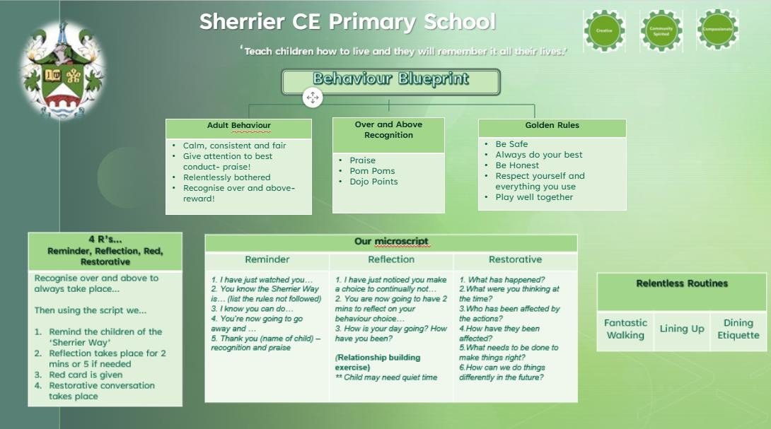


The Sherrier 3c’S are represented by cogs that show values at the heart of the school driving us all forward. We develop each individual at Sherrier to be –Community-Spirited, Compassionate and Creative
The expectations of behaviour in our school are also deeply rooted in our mission statement.

“Teach children how to live and they will remember it all their lives” (Proverbs 22:6)
We therefore aim to teach and encourage pupils to have high standards in all they do as this is a vital element when promoting the Sherrier Way. As leaders of the school we are committed to maintaining high standards of behaviour for learning and conduct at Sherrier by being positive role models for each other and our pupils.

We aim to achieve our mission statement in the following ways:
Community- we will teach children how we expect them to behave as part of the Sherrier community (in class, around the school and on the playground).
Compassion-Throughout their time at Sherrier, children will understand how to care for themselves, others and the world around them. When interacting with others and dealing with any behaviour concerns, staff at Sherrier will always do so with compassion.
Creativity- As part of the resolution to issues, children will learn how to look at incidents from other children’s point of view.
Children are supported to follow our school’s Golden Rules within assemblies and through our whole school approach to building positive relationships
The Jigsaw scheme of work promotes positive behaviour through a whole-school approach to PSHE (Personal, Social, Health Education) that integrates mindfulness, emotional literacy, and social skills. It aims to help children develop positive character traits, respect for others, and a strong sense of self, all while building their capacity for learning and equipping them for life.

The Sherrier Golden Rules encompass the traits we specifically encourage and set the standard of behaviour for The Sherrier Way
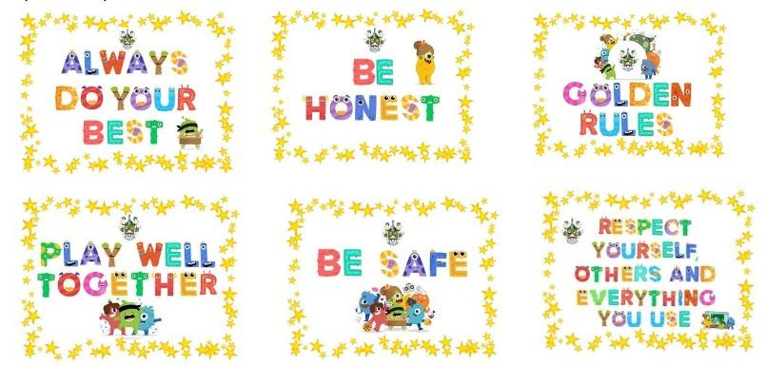

6.1 Mobile phones
Year 5 and 6 pupils only, are authorised to have mobile phones on-site. Their phones are to be switched off on entry to the classroom and are to be handed to an adult. Phones are then placed in a secure storage area and returned to pupils as they leave the building at the end of the school day.

7. Responding to behaviour
As a school we continually monitor and evaluate our Reward and Sanctions Systems and how they are applied throughout the school.
- The children’s views are always considered when evaluating and changing these at
Sherrier.
- We have a Behaviour Blueprint that promotes rights and responsibilities of staff, pupils and their families that incorporates high expectations of behaviour.
- At the start of the academic year, staff have input into revising the ‘Agreed
Expectations’ booklet and Blueprint that clearly outline The Sherrier Way of supporting and dealing with behaviour.
We feel it is very important to encourage appropriate behaviour at Sherrier and also to model and teach the different ways that this can be achieved. We focus our behaviour approach on positive relationships within our school community.

7.1 Classroom management
All staff are responsible for setting the tone and context for positive behaviour and relationships within the school.

7.2 Safeguarding
The school recognises that changes in behaviour may be an indicator that a pupil is in need of help or protection.
We will consider whether a pupil’s misbehaviour may be linked to them suffering, or being likely to suffer, significant harm.
Where this may be the case, we will follow our child protection and safeguarding policy, and consider whether pastoral support, an early help intervention or a referral to children’s social care is appropriate.
Please refer to our child protection and safeguarding policy for more information.

7.3 Responding to good behaviour
When a pupil’s behaviour meets or goes above and beyond the expected behaviour standard, staff will recognise it with positive recognition and reward. This provides an opportunity for all staff to reinforce the school’s culture and ethos.
Positive reinforcements and rewards will be applied clearly and fairly to reinforce the routines, expectations and norms of the school’s behaviour culture.
Positive behaviour will be rewarded with:
- Verbal and written praise
- Communicating praise to parents/carers via a phone call or written correspondence
- Star of the Week certificates/presentation
- Stickers from class teachers, support staff, phase leaders and SLT
- Dojo Points, which are logged on Class Dojo to share with parents • Visits to Headteacher for a ‘GEM Award’ (Going the Extra Mile)

7.4 Responding to misbehaviour
When a pupil’s behaviour falls below the standard that can reasonably be expected of them within our Golden Rules, staff will respond in order to restore a calm and safe learning environment, and to prevent recurrence of misbehaviour.
Staff will endeavour to create a predictable environment by always challenging behaviour that falls short of the standards, and by responding in a consistent, fair and proportionate manner, so pupils know with certainty that misbehaviour will always be addressed.
De-escalation techniques, including the use of pre-arranged scripts and phrases, will be used to help prevent further behaviour issues arising. Each adult in school will be given the following script to use.
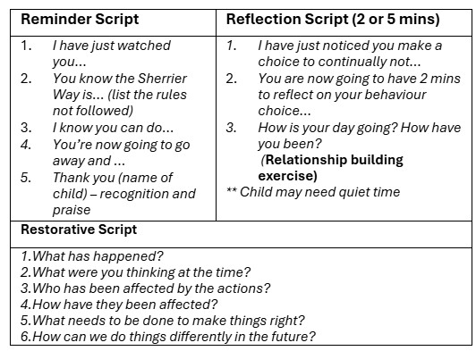
All pupils will be treated equitably under the policy, with any factors that contributed to the behavioural incident identified and taken into account.
When giving behaviour sanctions, staff will also consider what support could be offered to a pupil to help them to meet behaviour standards in the future and ensure no learning time is lost.

The school may use one or more of the following sanctions in response to unacceptable behaviour:

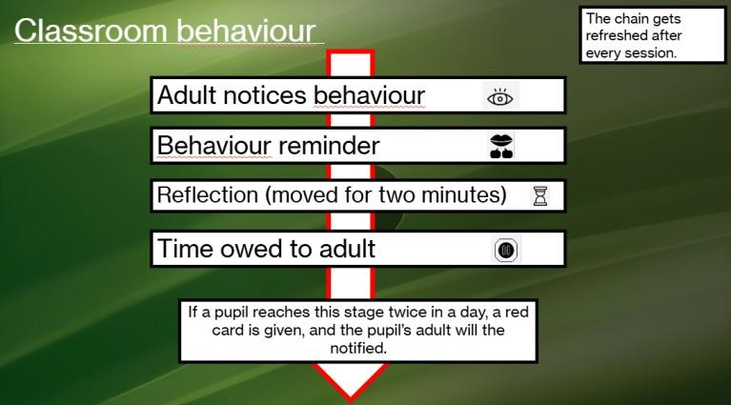
If a pupil demonstrates behaviour that is harmful or abusive, SLT will be called immediately.
Personal circumstances of the pupil will be taken into account when choosing sanctions, and decisions will be made on a case-by-case basis, but with regard to the impact on perceived fairness.

Responding to misbehaviour at lunchtime

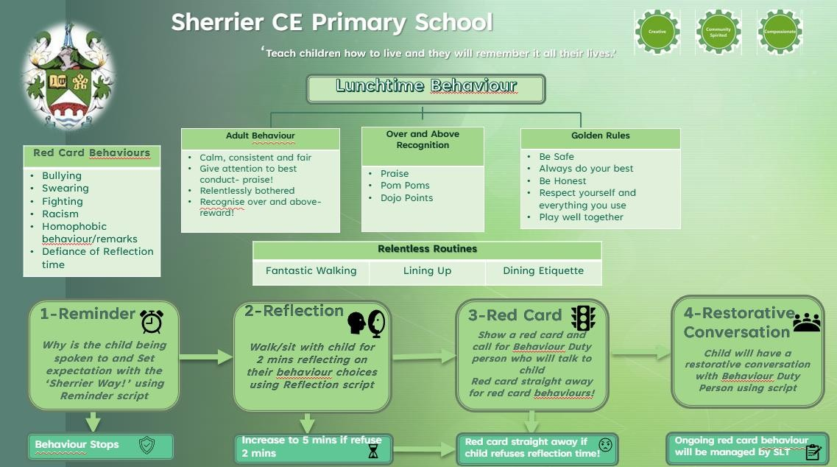

Restorative conversations are used in Sherrier to address misbehaviour because they focus on repairing harm and rebuilding relationships rather than simply punishing the child. This approach encourages children to reflect on their actions, understand the impact on others, and take responsibility. By fostering empathy and accountability, restorative conversations help create a supportive and respectful school environment where students learn from their mistakes and develop better social skills. This method promotes long-term positive behaviour and strengthens the community within the school.

7.5 Reasonable force
Reasonable force covers a range of interventions that involve physical contact with pupils. All members of staff have a duty to use reasonable force, in the following circumstances, to prevent a pupil from:
Causing disorder
Hurting themselves or others
Damaging property
Committing an offence
Incidents of reasonable force must:
Always be used as a last resort
Be applied using the minimum amount of force and for the minimum amount of time possible
Be used in a way that maintains the safety and dignity of all concerned
Never be used as a form of punishment
Be recorded and reported to parents/carers
When considering using reasonable force, staff should, in considering the risks, carefully recognise any specific vulnerabilities of the pupil, including SEND, mental health needs or medical conditions.

7.6 Searching, screening and confiscation
Searching, screening and confiscation is conducted in line with the DfE’s latest guidance on searching, screening and confiscation.

Confiscation
Any prohibited items (listed in section 3) found in a pupil’s possession as a result of a search will be confiscated. These items will not be returned to the pupil.
We will also confiscate any item that is harmful or detrimental to school discipline. These items will be returned to pupils after discussion with senior leaders and parents/carers, if appropriate.

Searching a pupil
Searches will only be carried out by a member of staff who has been authorised to do so by the headteacher, or by the headteacher themselves.
Subject to the exception below, the authorised member of staff carrying out the search will be of the same sex as the pupil, and there will be another member of staff present as a witness to the search.
An authorised member of staff of a different sex to the pupil can carry out a search without another member of staff as a witness if:
The authorised member of staff carrying out the search reasonably believes there is risk that serious harm will be caused to a person if the search is not carried out as a matter of urgency; and
In the time available, it is not reasonably practicable for the search to be carried out by a member of staff who is the same sex as the pupil; or
It is not reasonably practicable for the search to be carried out in the presence of another member of staff
When an authorised member of staff conducts a search without a witness, they should immediately report this to another member of staff, and make sure a written record of the search is kept.
If the authorised member of staff considers a search to be necessary, but not required urgently, they will seek the advice of the headteacher, designated safeguarding lead (or deputy) or pastoral member of staff who may have more information about the pupil. During this time the pupil will be supervised and kept away from other pupils.
A search can be carried out if the authorised member of staff has reasonable grounds for suspecting that the pupil is in possession of a prohibited item or any item identified in the school rules for which a search can be made, or if the pupil has agreed.
An appropriate location for the search will be found. Where possible, this will be away from other pupils. The search will only take place on the school premises or where the member of staff has lawful control or charge of the pupil, for example on a school trip.
Before carrying out a search the authorised member of staff will:
Assess whether there is an urgent need for a search
Assess whether not doing the search would put other pupils or staff at risk
Consider whether the search would pose a safeguarding risk to the pupil
Explain to the pupil why they are being searched
Explain to the pupil what a search entails – eg “I will ask you to turn out your pockets and remove your scarf”
Explain how and where the search will be carried out
Give the pupil the opportunity to ask questions
Seek the pupil’s co-operation
If the pupil refuses to agree to a search, the member of staff can give an appropriate behaviour sanction.
If they still refuse to co-operate, the member of staff will contact the headteacher, DSL or Pastoral Manager to try to determine why the pupil is refusing to comply.
The authorised member of staff will then decide whether to use reasonable force to search the pupil. This decision will be made on a case-by-case basis, taking into consideration whether conducting the search will prevent the pupil harming themselves or others, damaging property or causing disorder.
The authorised member of staff can use reasonable force to search for any prohibited items identified in section 3, but not to search for items that are only identified in the school rules.
The authorised member of staff may use a metal detector to assist with the search.
An authorised member of staff may search a pupil’s outer clothing, pockets, possessions, desk or locker.
‘Outer clothing’ includes:
Any item of clothing that is not worn wholly next to the skin or immediately over underwear (eg a jumper or jacket being worn over a t-shirt)
Hats, scarves, gloves, shoes or boots
Searching pupils’ possessions
Possessions means any items that the pupil has or appears to have control of, including: Desks
Lockers
Bags
A pupil’s possessions can be searched for any item if the pupil agrees to the search. If the pupil does not agree to the search, staff can still carry out a search for prohibited items (listed in section 3) and items identified in the school rules.
An authorised member of staff can search a pupil’s possessions when the pupil and another member of staff are present.
If there is a serious risk of harm if the search is not conducted immediately, or it is not reasonably practicable to summon another member of staff, the search can be carried out by a single authorised member of staff.

Informing the designated safeguarding lead (DSL)
The staff member who carried out the search should inform the DSL without delay:
Of any incidents where the member of staff had reasonable grounds to suspect a pupil was in possession of a prohibited item as listed in section 3
If they believe that a search has revealed a safeguarding risk
All searches for prohibited items (listed in section 3), including incidents where no items were found, will be recorded in the school’s safeguarding system.

Informing parents/carers
Parents/carers will always be informed of any search for a prohibited item (listed in section 3). A member of staff will tell the parents/carers as soon as is reasonably practicable:
What happened
What was found, if anything
What has been confiscated, if anything
What action the school has taken, including any sanctions that have been applied to their child

Support after a search
Irrespective of whether any items are found as the result of any search, the school will consider whether the pupil may be suffering or likely to suffer harm and whether any specific support is needed (due to the reasons for the search, the search itself, or the outcome of the search).
If this is the case, staff will follow the school’s safeguarding policy and speak to the designated safeguarding lead (DSL). The DSL will consider whether pastoral support, an early help intervention or a referral to children’s social care is appropriate.

Strip searches
The authorised member of staff’s power to search outlined above does not enable them to conduct a strip search (removing more than the outer clothing) and strip searches on school premises shall only be carried out by police officers in accordance with the Police and Criminal Evidence Act 1984 (PACE) Code C.
Before calling the police into school, staff will assess and balance the risk of a potential strip search on the pupil’s mental and physical wellbeing and the risk of not recovering the suspected item.
Staff will consider whether introducing the potential for a strip search through police involvement is absolutely necessary, and will always ensure that other appropriate, less invasive approaches have been exhausted first.
Once the police are on school premises, the decision on whether to conduct a strip search lies solely with them. The school will advocate for the safety and wellbeing of the pupil(s) involved. Staff retain a duty of care to the pupil involved and should advocate for pupil wellbeing at all times.

Communication and record-keeping
Where reasonably possible and unless there is an immediate risk of harm, before the strip search takes place, staff will contact at least one of the pupil’s parents/carers to inform them that the police are going to strip search the pupil, and ask them whether they would like to come into school to act as the pupil’s appropriate adult. If the school cannot get in touch with the pupil’s parents/carers, or if they are not able to come into school to act as the appropriate adult, a member of staff can act as the appropriate adult (see below for information about the role of the appropriate adult).
The pupil’s parents/carers will always be informed by a staff member once a strip search has taken place. The school will keep records of strip searches that have been conducted on school premises and monitor them for any trends that emerge.

Who will be present
For any strip search that involves exposure of intimate body parts, there will be at least two people present other than the pupil, except in urgent cases where there is risk of serious harm to the pupil or others. One of these must be the appropriate adult, except if: • The pupil explicitly states in the presence of an appropriate adult that they do not want an appropriate adult to be present during the search, and • The appropriate adult agrees If this is the case, a record will be made of the pupil’s decision, and it will be signed by the appropriate adult. No more than two people other than the pupil and appropriate adult will be present, except in the most exceptional circumstances. The appropriate adult will: Act to safeguard the rights, entitlements and welfare of the pupil Not be a police officer or otherwise associated with the police Not be the headteacher Be of the same sex as the pupil, unless the pupil specifically requests an adult who is not of the same sex Except for an appropriate adult of a different sex if the pupil specifically requests it, no one of a different sex will be permitted to be present and the search will not be carried out anywhere where the pupil could be seen by anyone else.

Care after a strip search
After any strip search, the pupil will be given appropriate support, irrespective of whether any suspected item is found. The pupil will also be given the opportunity to express their views about the strip search and the events surrounding it.
As with other searches, the school will consider whether the pupil may be suffering or likely to suffer harm and whether any further specific support is needed (due to the reasons for the search, the search itself, or the outcome of the search).
Staff will follow the school’s safeguarding policy and speak to the designated safeguarding lead (DSL). The DSL will consider whether, in addition to pastoral support, an early help intervention or a referral to children’s social care is appropriate.
Any pupil(s) who have been strip searched more than once and/or groups of pupils who may be more likely to be subject to strip searching will be given particular consideration, and staff will consider any preventative approaches that can be taken.

7.7 Off-site misbehaviour
Sanctions may be applied where a pupil has misbehaved off-site when representing the school. This means misbehaviour when the pupil is:
Taking part in any school-organised or school-related activity (eg school trips)
Travelling to or from school
Wearing school uniform
In any other way identifiable as a pupil of our school
Sanctions may also be applied where a pupil has misbehaved off-site, at any time, whether or not the conditions above apply, if the misbehaviour:
Could have repercussions for the orderly running of the school
Poses a threat to another pupil
Could adversely affect the reputation of the school
Sanctions will only be given out on school premises or elsewhere when the pupil is under the lawful control of a staff member (eg on a school-organised trip).

7.8 Online misbehaviour
The school can issue behaviour sanctions to pupils for online misbehaviour when:
It poses a threat or causes harm to another pupil
It could have repercussions for the orderly running of the school
It adversely affects the reputation of the school
The pupil is identifiable as a member of the school
Sanctions will only be given out on school premises or elsewhere when the pupil is under the lawful control of a staff member.

7.9 Suspected criminal behaviour
If a pupil is suspected of criminal behaviour, the school will make an initial assessment of whether to report the incident to the police.
When establishing the facts, the school will endeavour to preserve any relevant evidence to hand over to the police.
If a decision is made to report the matter to the police, the headteacher will make the report.
The school will not interfere with any police action taken. However, the school may continue to follow its own investigation procedure and enforce sanctions, as long as it does not conflict with police action.
If a report to the police is made, the designated safeguarding lead (DSL) will make a tandem report to children’s social care, if appropriate.

7.10 Zero-tolerance approach to sexual harassment and sexual violence
The school will ensure that all incidents of sexual harassment and/or violence are met with a suitable response, and never ignored. Pupils are encouraged to report anything that makes them uncomfortable, no matter how ‘small’ they feel it might be. The school’s response will be:
Proportionate
Considered
Supportive

Decided on a case-by-case basis
The school has procedures in place to respond to any allegations or concerns regarding a child’s safety or wellbeing. These include clear processes for: Responding to a report carrying out risk assessments, where appropriate, to help determine whether to:
o Manage the incident internally o Refer to early help
o Refer to children’s social care o Report to the police

Please refer to our child protection and safeguarding policy for more information

7.11 Malicious allegations
Where a pupil makes an allegation against a member of staff and that allegation is shown to have been deliberately invented or malicious, the school will consider whether to discipline the pupil in accordance with this policy.
Where a pupil makes an allegation of sexual violence or sexual harassment against another pupil and that allegation is shown to have been deliberately invented or malicious, the school will consider whether to discipline the pupil in accordance with this policy.
In all cases where an allegation is determined to be unsubstantiated, unfounded, false or malicious, the school (in collaboration with the local authority designated officer (LADO), where relevant) will consider whether the pupil who made the allegation is in need of help, or the allegation may have been a cry for help. If so, a referral to children’s social care may be appropriate.
The school will also consider the pastoral needs of staff and pupils accused of misconduct.
Please refer to our trust policy on allegations of abuse made against staff, and procedures for dealing with allegations of abuse against staff for more information on responding to allegations of abuse against staff or other pupils.
8. Serious sanctions

8.1 Detention
Detentions are not part of our behaviour policy; however, when a red card has been given children will be given time to discuss with an adult and reflect on their choices through a restorative conversation.

8.2 Removal from classrooms
In response to serious or persistent breaches of this policy, the school may remove the pupil from the classroom for a limited time. Pupils who have been removed will continue to receive education under the supervision of a member of staff. This education will be meaningful, but it may differ from the mainstream curriculum. Removal is a serious sanction and will only be used in response to serious misbehaviour. Staff will only remove pupils from the classroom once other behavioural strategies have been attempted, unless the behaviour is so extreme as to warrant immediate removal.
Removal can be used to:
- Restore order if the pupil is being unreasonably disruptive
- Maintain the safety of all pupils Allow the disruptive pupil to continue their learning in a managed environment

- Allow the disruptive pupil to regain calm in a safe space
Pupils who have been removed from the classroom are supervised by a member of staff from that classroom, class teacher or support staff, and will be removed for a maximum of one lesson. Pupils will not be removed from classrooms for prolonged periods of time without the explicit agreement of the headteacher. Pupils should be reintegrated into the classroom as soon as it is appropriate and safe to do so. The school will consider what support is needed to help a pupil successfully reintegrate into the classroom and meet the expected standards of behaviour. Parents/carers will be informed on the same day that their child is removed from the classroom.
The school will consider an alternative approach to behaviour management for pupils who are frequently removed from class. Staff will record all incidents of removal from the classroom in the behaviour log (CPOMS), along with details of the incident that led to the removal, and any protected characteristics of the pupil.

8.3 Suspension and permanent exclusion
The school can use suspension and permanent exclusion in response to serious incidents or in response to persistent poor behaviour which has not improved following in-school sanctions and interventions.
The decision to suspend or exclude will be made by the headteacher and only as a last resort.
Please refer to our suspensions and exclusions guidance for more information.

9. Responding to misbehaviour from pupils with SEND

9.1 Recognising the impact of SEND on behaviour
The school recognises that pupils’ behaviour may be impacted by a special educational need or disability (SEND).
When incidents of misbehaviour arise, we will consider them in relation to a pupil’s SEND, although we recognise that not every incident of misbehaviour will be connected to their SEND. Decisions on whether a pupil’s SEND had an impact on an incident of misbehaviour will be made on a case-by-case basis.
When dealing with misbehaviour from pupils with SEND, especially where their SEND affects their behaviour, the school will take its legal duties into account when making decisions about enforcing the behaviour policy. The legal duties include:
Taking reasonable steps to avoid any substantial disadvantage to a disabled pupil being caused by the school’s policies or practices (Equality Act 2010)
Using our best endeavours to meet the needs of pupils with SEND (Children and Families Act 2014)
If a pupil has an education, health and care (EHC) plan, the provisions set out in that plan must be secured and the school must co-operate with the local authority and other bodies
As part of meeting these duties, the school will anticipate, as far as possible, all likely triggers of misbehaviour, and put in place support to prevent these from occurring.
Any preventative measures will take into account the specific circumstances and requirements of the pupil concerned.
Our approach to anticipating and removing triggers of misbehaviour include examples such as:
Short, planned movement breaks for a pupil with SEND who finds it difficult to sit still for long
Adjusting seating plans to allow a pupil with visual or hearing impairment to sit in sight of the teacher
Adjusting uniform requirements for a pupil with sensory issues or who has severe eczema
Training for staff in understanding conditions such as autism
Use of separation spaces (sensory zones or nurture rooms) where pupils can regulate their emotions during a moment of sensory overload

9.2 Adapting sanctions for pupils with SEND
When considering a behavioural sanction for a pupil with SEND, the school will consider whether:
The pupil was unable to understand the rule or instruction
The pupil was unable to act differently at the time as a result of their SEND
The pupil was likely to behave aggressively due to their particular SEND
If the answer to any of these is ‘yes’, it may be unlawful for the school to sanction the pupil for the behaviour.
The school will then assess whether it is appropriate to use a sanction and if so, whether any reasonable adjustments need to be made to the sanction.

9.3 Considering whether a pupil displaying challenging behaviour may have unidentified SEND
The school’s special educational needs co-ordinator (SENCO) may evaluate a pupil who exhibits challenging behaviour to determine whether they have any underlying needs that are not currently being met.
Where necessary, support and advice will also be sought from specialist teachers, an educational psychologist, medical practitioners and/or others, to identify or support specific needs.
When acute needs are identified in a pupil, we will liaise with external agencies and plan support programmes for that child. We will work with parents/carers to create the plan and review it on a regular basis.

9.4 Pupils with an education, health and care (EHC) plan
The provisions set out in the EHC plan must be secured and the school will co-operate with the local authority and other bodies.
If the school has a concern about the behaviour of a pupil with an EHC plan, it will make contact with the local authority to discuss the matter. If appropriate, the school may request an emergency review of the EHC plan.

10. Supporting pupils following a sanction
Following a sanction, the school will consider strategies to help the pupil to understand how to improve their behaviour and meet the expectations of the school.
This could include measures such as:
Individual meeting with class teacher/support staff
Individualised positive interventions (sticker chart etc)
Reintegration meetings
Daily contact with the pastoral lead or other trusted adults
Writing of Behaviour Support Plans to detail how improvements will be made and monitored

11. Pupil transition

11.1 Inducting incoming pupils
The school will support incoming pupils to meet behaviour standards by offering an induction process to familiarise them with the behaviour policy and the wider school culture.

11.2 Preparing outgoing pupils for transition
To ensure a smooth transition to the next year, pupils have transition sessions with their new teacher(s). In addition, staff members hold transition meetings.
To ensure behaviour is continually monitored and the right support is in place, information relating to pupil behaviour issues may be transferred to relevant staff at the start of the term or year.

12. Training
As part of their induction process, our staff are provided with regular training on managing behaviour, including training on:
The needs of the pupils at the school
How SEND and mental health needs can impact behaviour
How ACE’s may impact behaviour
How to adhere to our behaviour policy
The proper use of restraint
How to utilise ‘The Sherrier Way’ approach to behaviour (Blueprints and classroom flowchart)

13. Monitoring arrangements

13.1 Monitoring and evaluating behaviour
The school will collect data on the following:
Behavioural incidents, including removal from the classroom
Attendance, permanent exclusions and suspensions
Use of pupil support units, off-site directions and managed moves
Incidents of searching, screening and confiscation
Perceptions and experiences of the school behaviour culture for staff, pupils, governors, and other stakeholders (via anonymous surveys)
Incidents of behaviour needing recording are reviewed weekly by the Sherrier DSL Team The data aligned will be analysed every term by DSL team.
The data will be analysed from a variety of perspectives including:
At school level
By age group
At the level of individual members of staff
By time of day/week/term
By protected characteristic
The school will use the results of this analysis to make sure it is meeting its duties under the Equality Act 2010. If any trends or disparities between groups of pupils are identified by this analysis, the school will review its policies to tackle them.

13.2 Monitoring this policy
This behaviour policy will be reviewed by the headteacher and Trust Leader at least annually, or more frequently, if needed, to address findings from the regular monitoring of the behaviour data (as per section 13.1). At each review, the policy will be approved by
SLT.

14. Links with other policies
This behaviour policy is linked to the following policies
Exclusions policy
Child protection and safeguarding policy
Mobile phone policy

Written statement of behaviour principles
Every pupil understands they have the right to feel safe, valued and respected, and to be able to learn free from the disruption of others.
- All pupils, staff and visitors are free from any form of discrimination
- Staff and volunteers set an excellent example to pupils at all times
- Rewards, sanctions and reasonable force are used consistently by staff, in line with the behaviour policy
- The behaviour policy is understood by pupils and staff
- The suspensions and exclusions policy explains that exclusions will only be used as a last resort, and outlines the processes involved in suspensions and exclusions
- Pupils are helped to take responsibility for their actions
- Families and carers are involved in the handling of behaviour incidents to foster good relationships between the school and pupils’ home life
- The board of trustees and local governing committee also emphasise that violence or threatening behaviour will not be tolerated in any circumstances.

Appendix 1: Text of letter to parents/carers about pupil behaviour – templates
Behaviour message (to be used when a phone call has not been answered)

Dear [Parent/Carer’s Name],

I am writing to inform you about an incident that occurred today involving [student’s name]. During [time of day], [student’s name] displayed behaviour that was unsafe or stopped others from effective learning.
At Sherrier, we take such incidents very seriously and have addressed the situation in accordance with our behaviour policy.
[Student’s name] has been given time to reflect on their choice and as far as we are concerned, the incident has been dealt with and we look forward to them moving on and showing us the great behaviour we know they are capable of.

Thank you for your understanding and support.

Kind regards,

[Your Name]

Page | 25

All you need to know about red cards

Given in lessons

- A red card can be given for a cumulation of bad choices in one day. After 2 times through the flowchart of behaviour in one day a red card will be given.
- The member of staff in charge of the class will ring parents to inform them of the red card given at an appropriate time on the same day
- The red card will be logged as Red Card Inside or Red Card Outside on Cpoms
- When talking to parents there will be a reminder that the consequence is to miss part of playtime the next day

Given at playtime
- A red card can be given after following the Reminder and Reflection time as appropriate or if a serious breach of the policy eg racism, homophobic comments
- The Lunchtime Manager will then be called to undertake the restorative conversation
- The Lunchtime Manager will phone the parents to inform of the red card and will record on CPOMS

Given at lunchtime

- A red card can be given after following the Reminder and Reflection time as appropriate or if a serious breach of the policy eg racism, homophobic comments
- A SLT member will then be called to undertake the restorative conversation
- The SLT member will phone the parents to inform of the red card and will record on CPOMS

Red Card Reflection Time

- The Red Card Reflection Time will be during playtime in the Library and will be taken by a DSL
- There is a Reflection Book that the children’s reflections will be recorded in

